**Setting Up a Development Environment in AWS Using Terraform and VS Code**

This guide walks you through setting up a development environment in AWS using Terraform and Visual Studio Code (VS Code). It covers everything from creating resources in AWS to configuring SSH and Docker.

1. **Setting Up the provider.tf File**

The **provider.tf** file is essential for Terraform to interact with the AWS API and manage infrastructure.

**Steps:**

1. Add the AWS provider block in your **provider.tf** file. Reference the Terraform documentation for details: [AWS Provider Documentation](https://registry.terraform.io/providers/hashicorp/aws/latest/docs).
2. Include your AWS credentials. Use the shared credentials format to avoid hardcoding sensitive information.
   * As this blog is aimed to show you how to set up a Dev environment, I will not be going into how to set up IAM users and credentials. For details on setting up IAM users and credentials, refer to YouTube tutorials or Medium articles.
3. Run **terraform init** to:
   * Initialize the working directory.
   * Download necessary provider plugins and modules.
   * Set up the backend for storing infrastructure state.

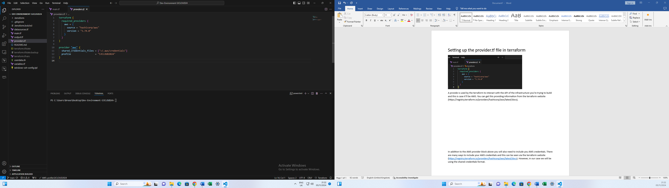

1. **Setting Up the main.tf File**

The **main.tf** file defines the resources you want to create in AWS.

**Steps:**

**2.1 Create an AWS VPC (Virtual Private Cloud)**

* Define the VPC resource in **main.tf**.
* Assign a name (e.g., "Dev") to your VPC.

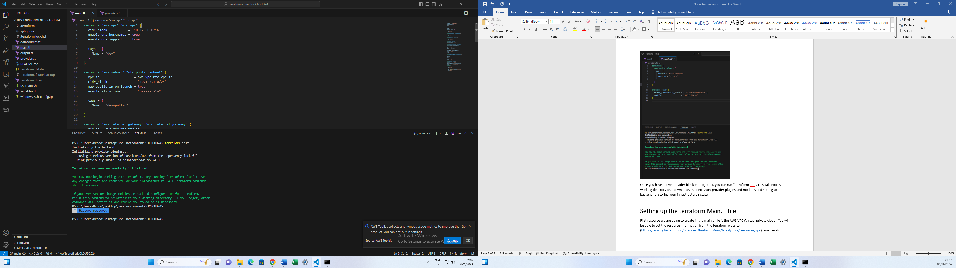

**Reference:** [VPC Resource Documentation](https://registry.terraform.io/providers/hashicorp/aws/latest/docs/resources/vpc).

**2.2 Add a Public Subnet**

* Define a public subnet within the VPC.
* Include the following arguments:
  + map_public_ip_on_launch: Ensures instances launched in this subnet get a public IP address.
  + vpc_id: Links the subnet to your VPC.
  + cidr_block and availability_zone: Configure IP ranges and availability zones.

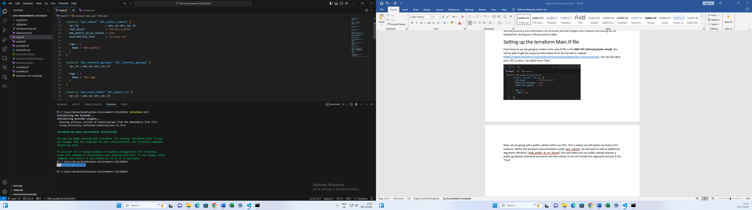

**2.3 Create an Internet Gateway**

* Add an internet gateway to provide internet access to resources in the VPC.

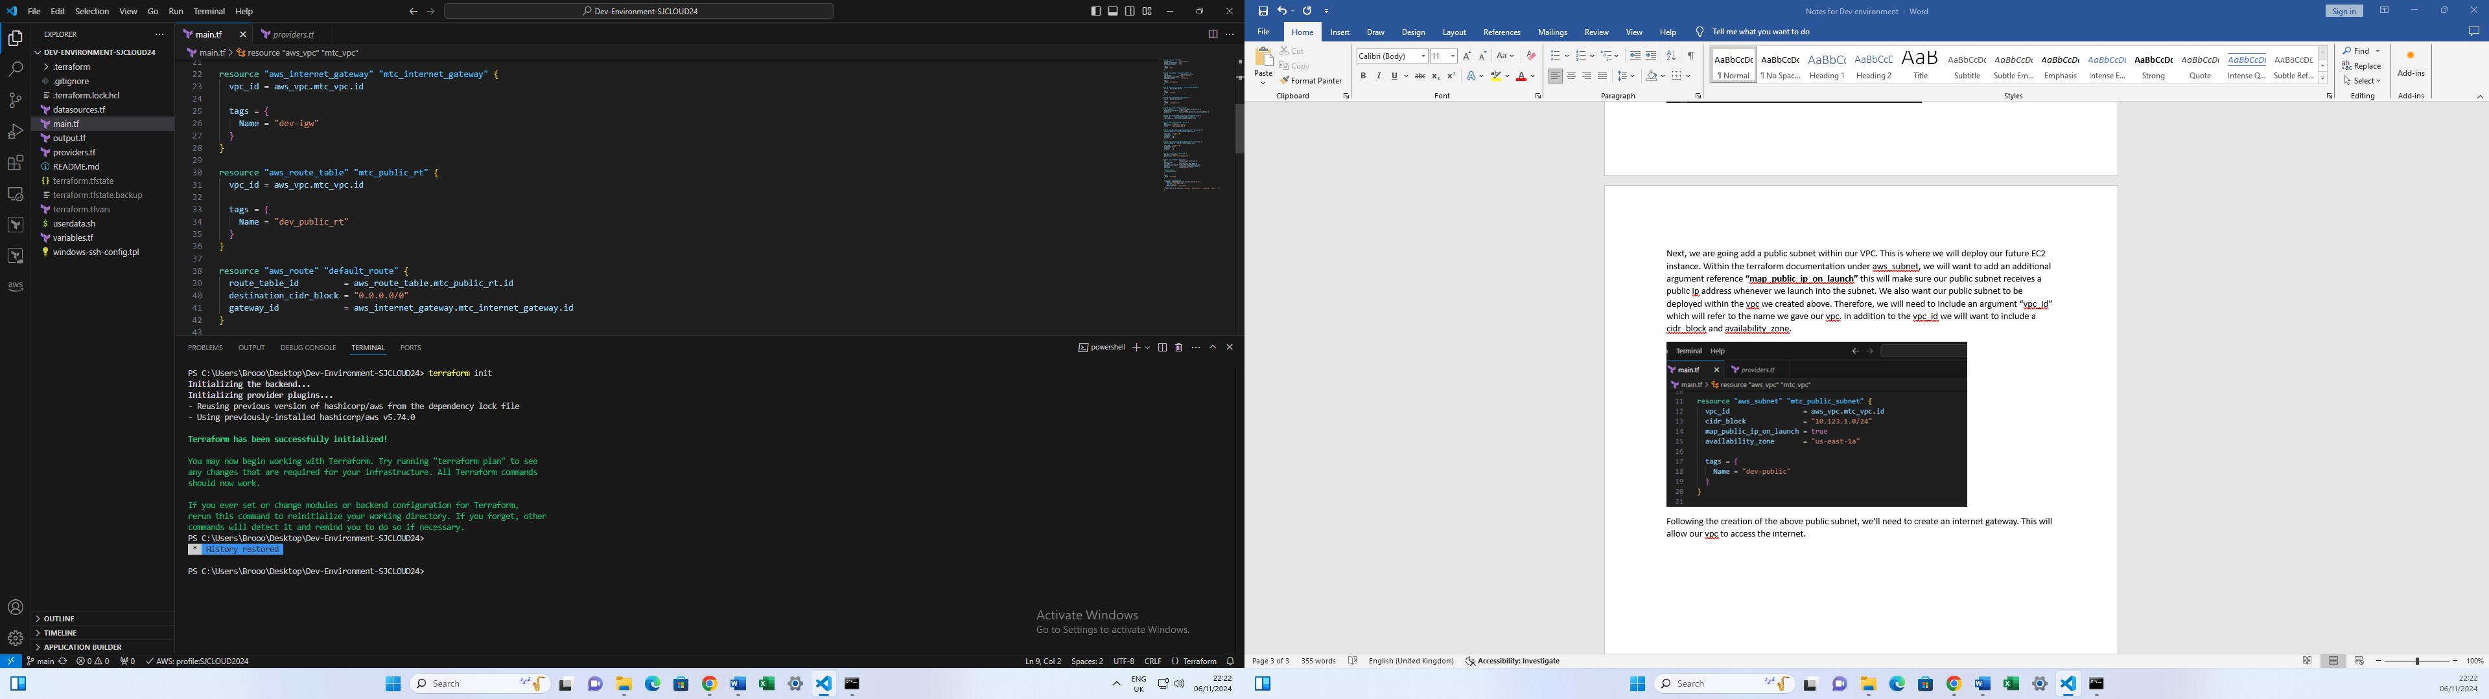

**2.4 Configure a Route Table**

* Create a route table to route traffic from the subnet to the internet gateway.
* Create a route association table to link the route table to the subnet.

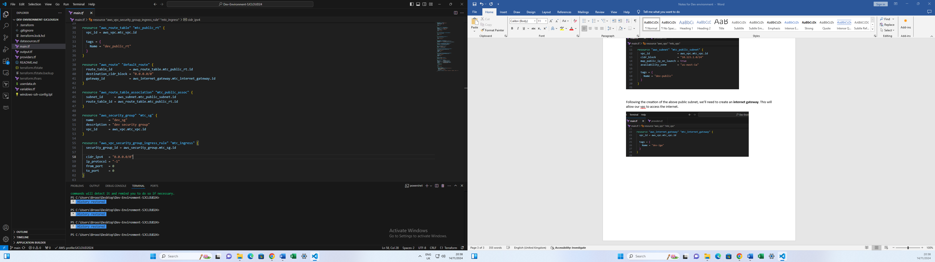

**2.5 Add Security Groups**

* Define security groups to control inbound and outbound traffic for your EC2 instance. These act as a virtual firewall to protect resources.

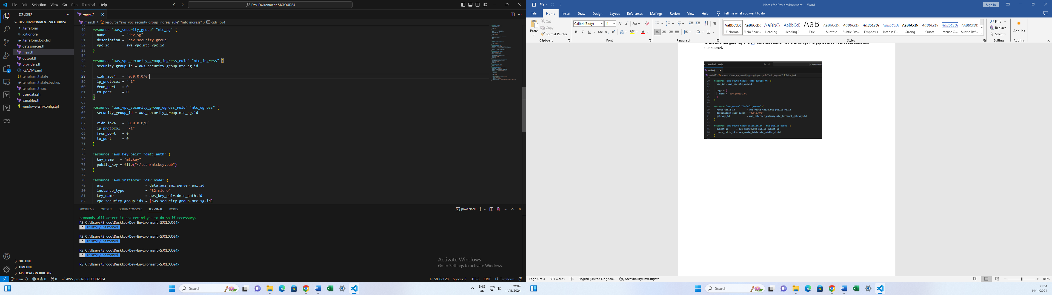

1. **Working with AMIs (Amazon Machine Images)**

To deploy an EC2 instance, you need to specify an AMI.

**Steps:**

1. Use the EC2 AMI browser to find a suitable AMI (e.g., Ubuntu).

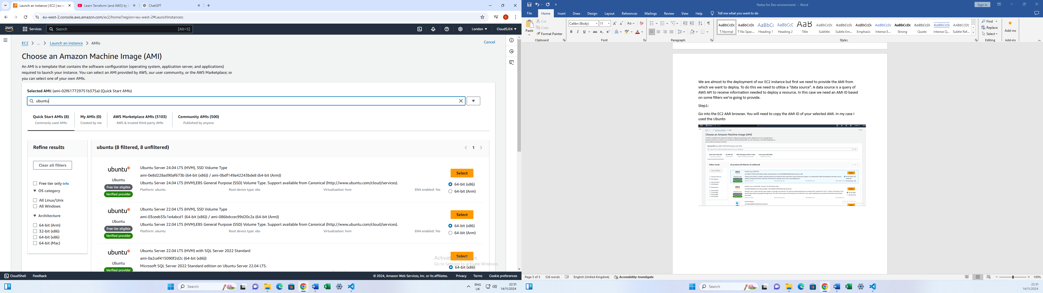

1. Copy the AMI ID and owner code.

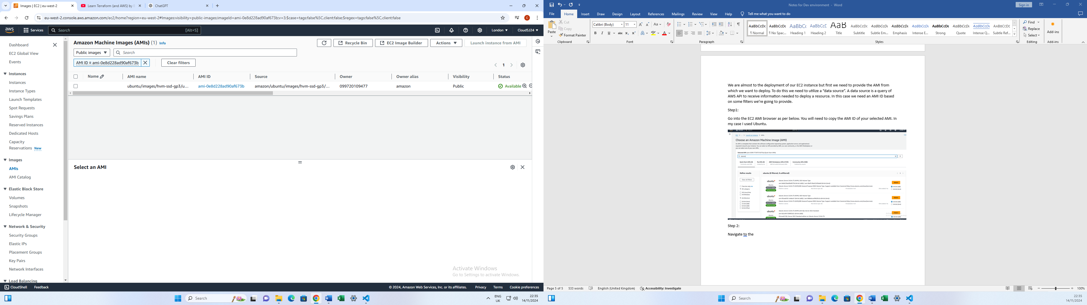

1. Create a datasources.tf file to define a data source for the AMI.
   * Use filters to ensure the latest AMI is selected dynamically.

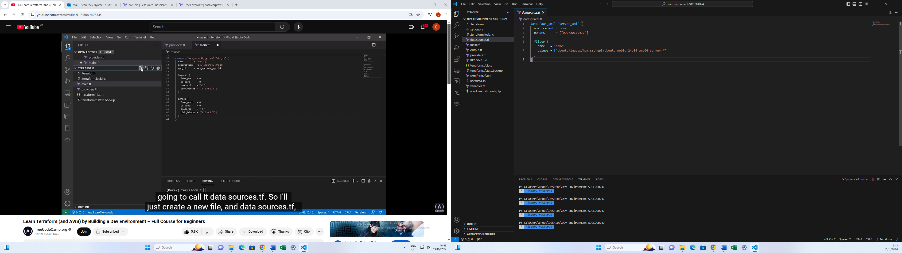

1. **Generating an SSH Key Pair**

An SSH key pair is required to securely access your EC2 instance

**Steps:**

1. Run the following command to generate a key pair:

ssh-keygen -t ed25519

1. Save the key pair (e.g., mtckey).
2. Verify the key pair in the .ssh folder using:

ls ~/.ssh

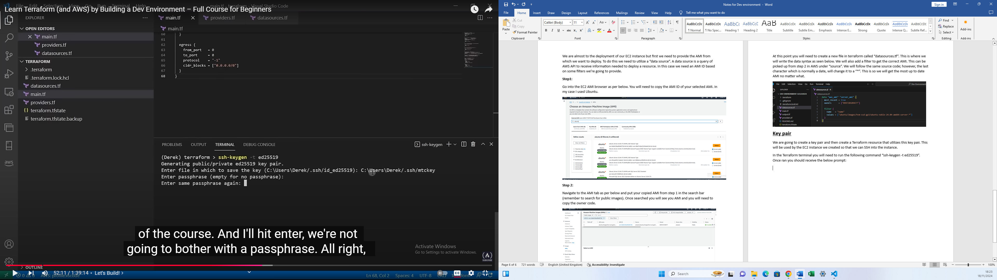

1. Add the public key to your main.tf file:

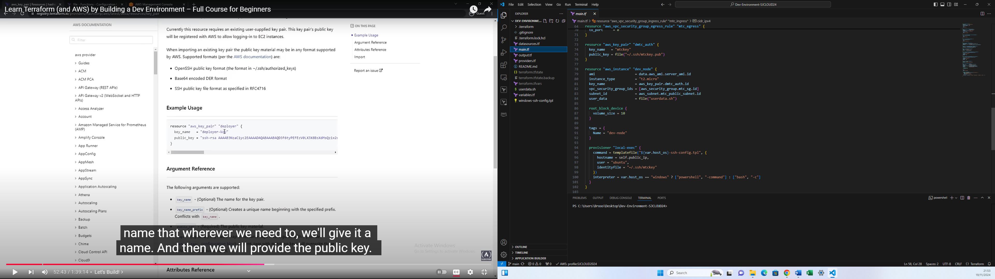

**5. Creating an EC2 Instance**

Define an EC2 instance in your main.tf file. Reference resources like:

* AMI
* Instance type
* Key pair
* Security group
* Subnet
* User data (see below)

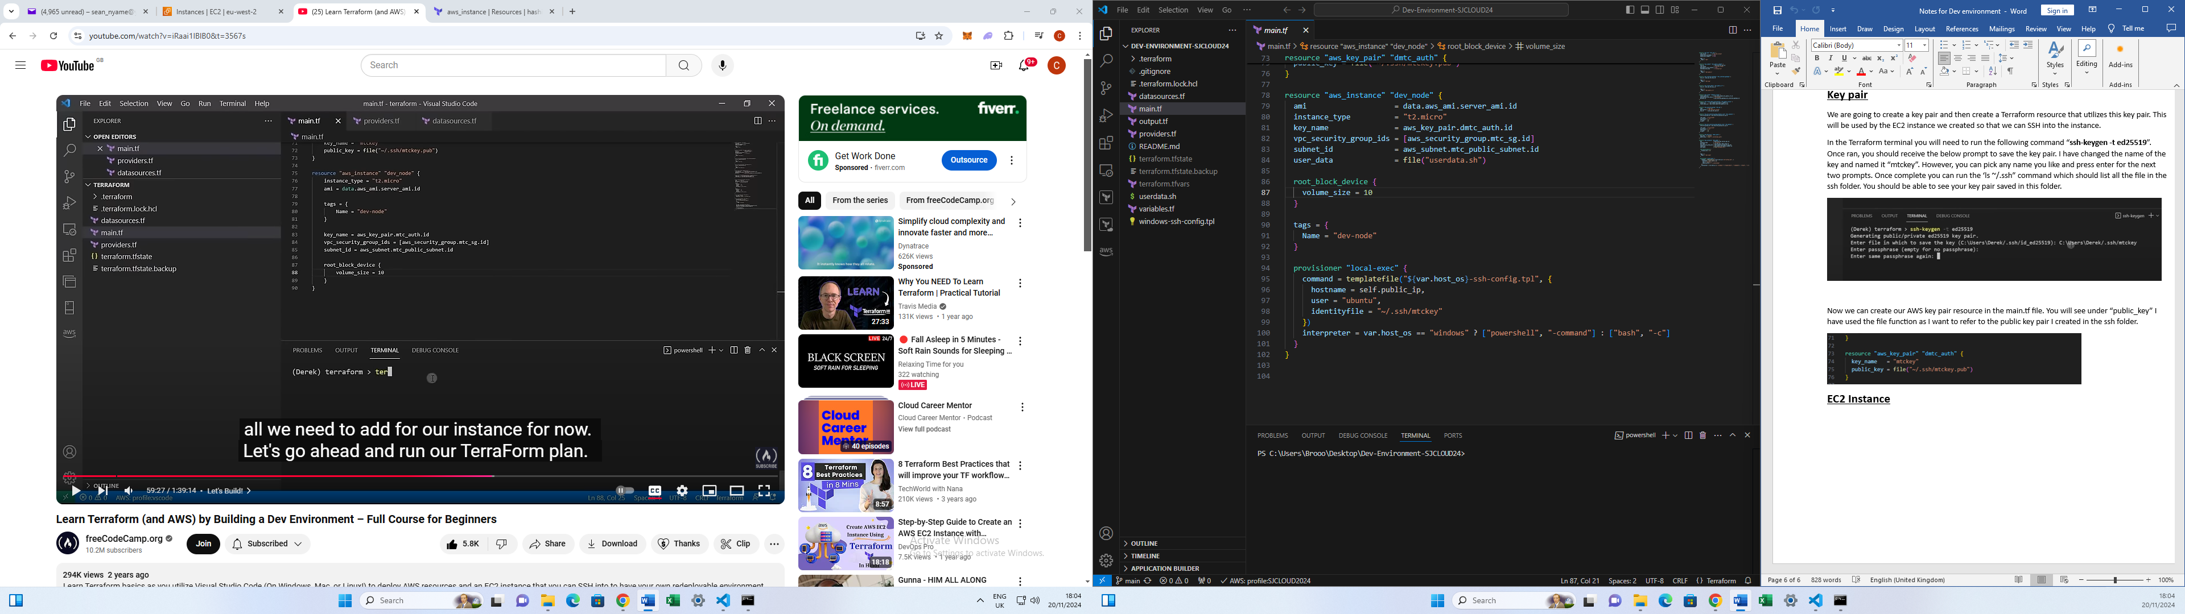

**User Data Script**

Use a user data script to bootstrap the instance with Docker:

Create a new file called “userdata.sh” and insert the below script.

**#!/bin/bash**

**sudo apt-get update -y &&**

**sudo apt-get install -y \**

**apt-transport-https \**

**ca-certificates \**

**curl \**

**gnupg-agent \**

**software-properties-common &&**

**curl -fsSL https://download.docker.com/linux/ubuntu/gpg | sudo apt-key add - &&**

**sudo add-apt-repository -y "deb [arch=amd64] https://download.docker.com/linux/ubuntu $(lsb_release -cs) stable" &&**

**sudo apt-get update -y &&**

**sudo apt-get install -y docker-ce docker-ce-cli containerd.io &&**

**sudo usermod -aG docker ubuntu**

1. **Testing SSH connectivity and Docker**

**Steps:**

1. Run the following Terraform commands in VS Code:
2. terraform init
3. terraform plan
4. terraform apply
5. After deployment, get the public IP address of the EC2 instance from the AWS console.
6. SSH into the instance:

ssh -i ~/.ssh/mtckey ubuntu@<public-ip-address>

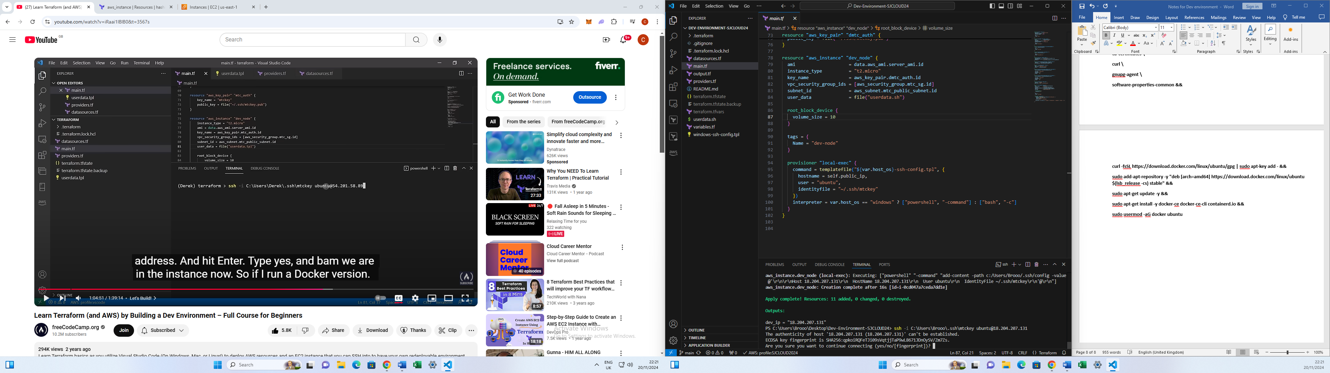

1. Verify Docker installation:

docker –version

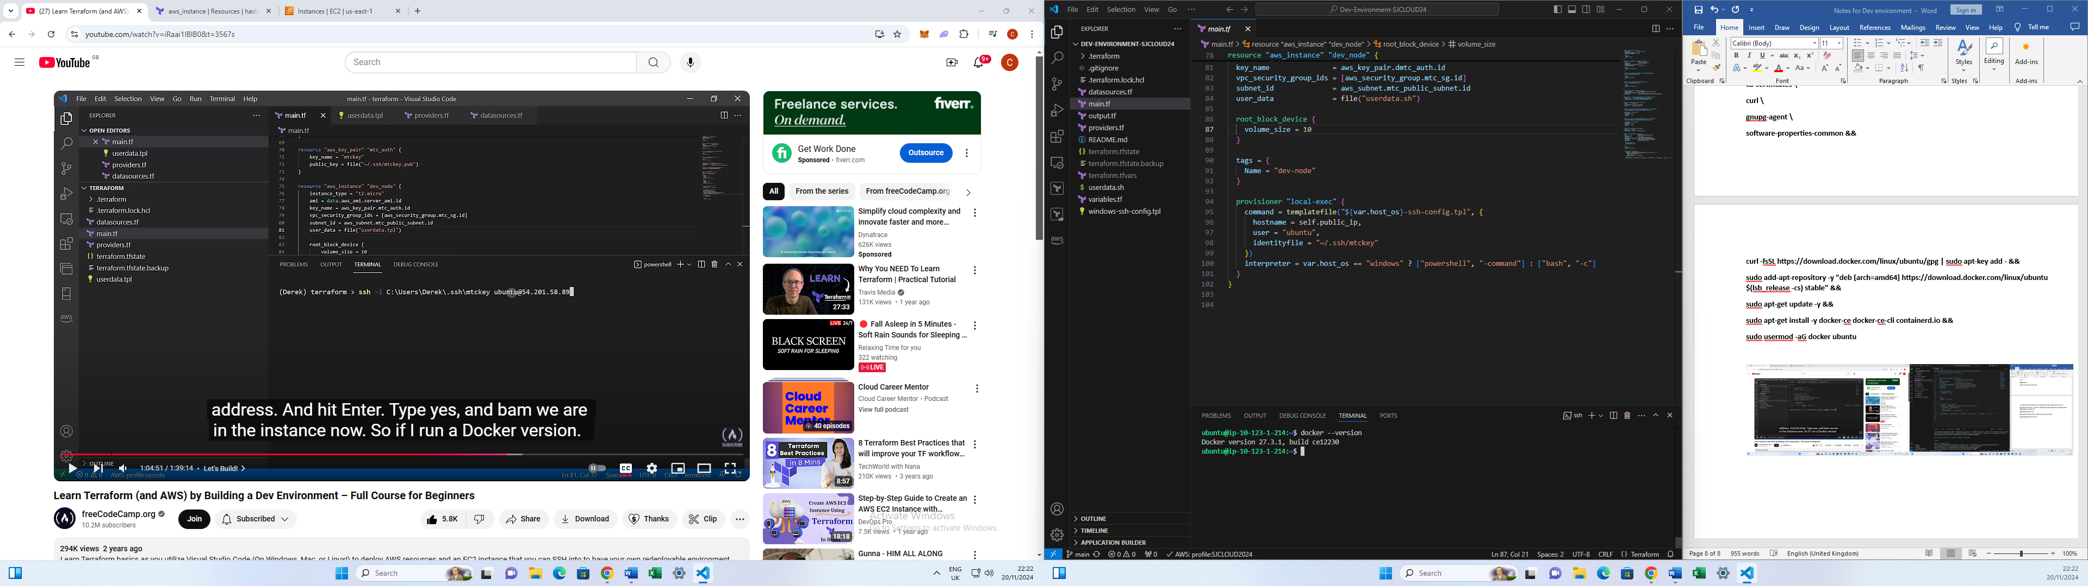

**7. Configuring VS Code for SSH**

**Steps:**

1. Install the "Remote - SSH" extension in VS Code.

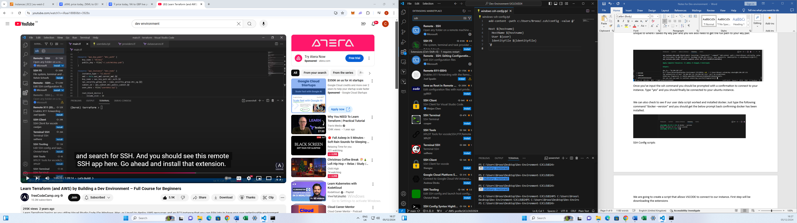

1. Check config file in .ssh folder:

Once installed, you should have a config file saved in your ssh folder. In order to check this, you can type “cat ~/.ssh/config” in the VSCOSE terminal. You should see the below displayed. The below shows the host, hostname and user of which we will use to login.

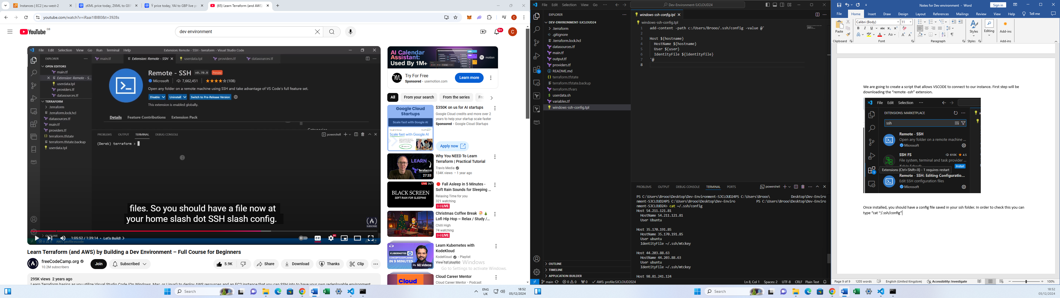

1. Create a new temaplte file for ssh config script:

To write the script we will need to use a template file. You will need to create a file based on your operating system whether you’re on windows, linux or Mac. Linux and Mac can use the same script. However, windows is going to be different. I’m going to call the new template file “windows-ssh-config.tpl”.

The script for this windows file is:

**add-content -path c:/Users/*Brooo*/.ssh/config -value @'**

**Host ${hostname}**

**HostName ${hostname}**

**User ${user}**

**IdentityFile ${identityfile}**

**'@**

Within this script you will need to change the first line which contains the full path to the config file stored in on your PC (underlined). Lines 2-5 will add the hostname, user and identity file to our config. What we are doing in this script is specifying the hostname, user and identity file from our provisioner section in the **main.ft** file. However, before we create the provisioner section you will need to save your tpl file.

**8. Using Terraform Variables**

We are also going to use variable to start optimizing our script and making it more dynamic.

**Steps:**

1. Create a **variables.tf** file:
2. variable "host_os" {
3. default = "windows"

}

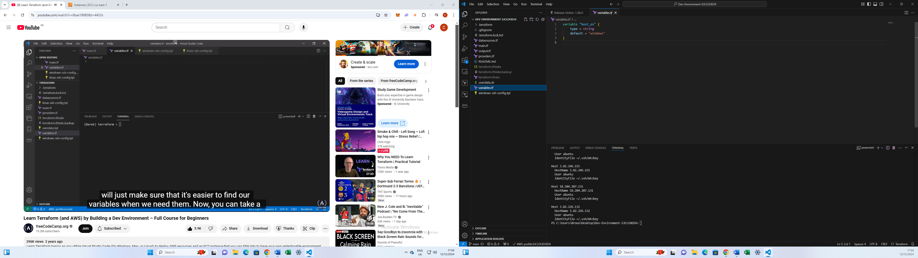

1. Create a **terraform.tfvars** file to define variable values:

host_os = "windows"

We are also going to create another file called “terraform.tfvars” as per below which will be our default name for our variable definition file. What we’ll need to do is define our host_os which will be “windows”.

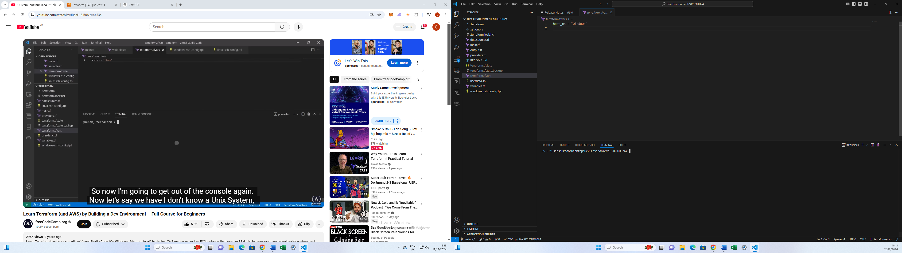

1. **Provisioning with Terraform**

In this section, we will utilize a provisioner in our **main.tf** file to configure VSCode on our local terminal, enabling us to SSH into our EC2 instance. Specifically, we will use the local-exec provisioner, which allows us to run commands and configure our local machine.

It is important to note that **provisioners** are always executed within the context of another resource. In our case, the local-exec provisioner will run commands that help set up SSH access seamlessly.

Additionally, we will use the self.public_ip syntax to access the public IP address of the EC2 instance. The self attribute allows us to retrieve resource-specific information such as public and private IP addresses, making it flexible and useful when dynamically referencing resource properties.

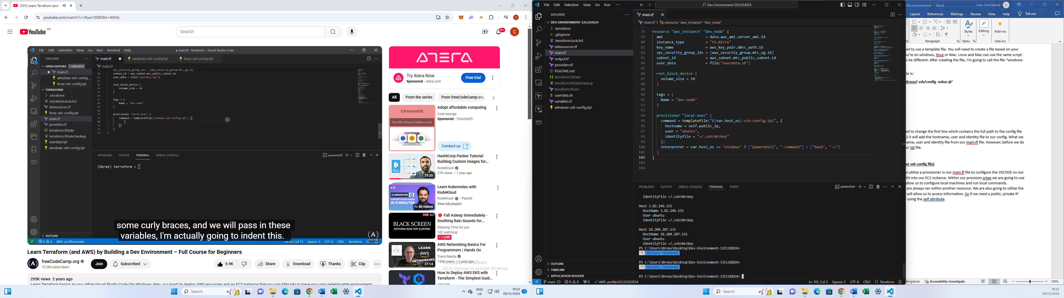

**Key Note: the provisioner resource needs to be within the instance resources as per above snapshot.**

At this point you can write terraform init, plan and apply in the VSCODE terminal. Once your instances has been created and the 2 status checks confirmed, go back to VSCODE and type “cat ~/.ssh/config”. This should show the hostname, user and identity-file as per below. The IP address for the host and hostname should match your public IP address within your instance.

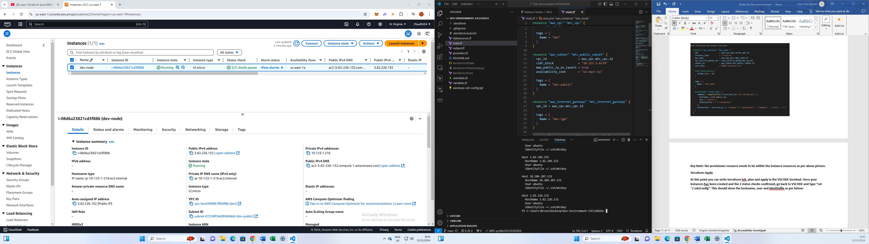

Now we can check if we can access our dev environment via the SHH host in VSCODE.

**Step1:** go to ‘view’ in the top ribbon and click on ‘command palette’, then search “ssh connect to host”.

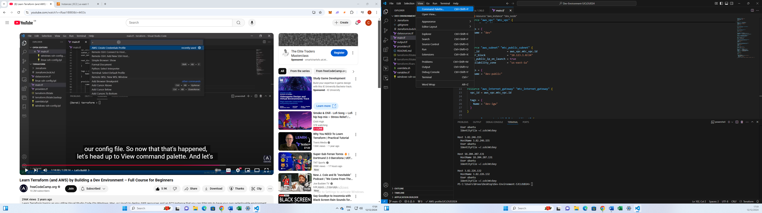

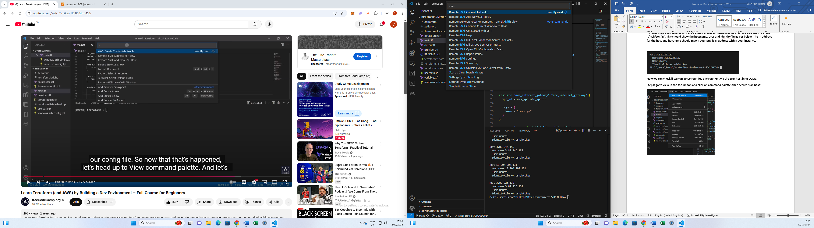

**Step2:** you should be able to see your public IP address from your EC2 instance within the search bar. Once located click on your public IP address, then click on Linux as we our instance is a ubuntu Linux machine. Press ‘continue’ and at this point a new VSCODE window should pop up. Open a new terminal in VSCODE and you should now in active within your dev ubuntu instance. Your IP address should match your private IP address of your instance in AWS console.

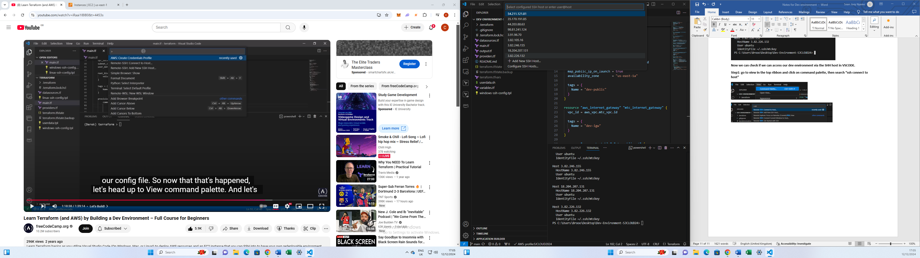

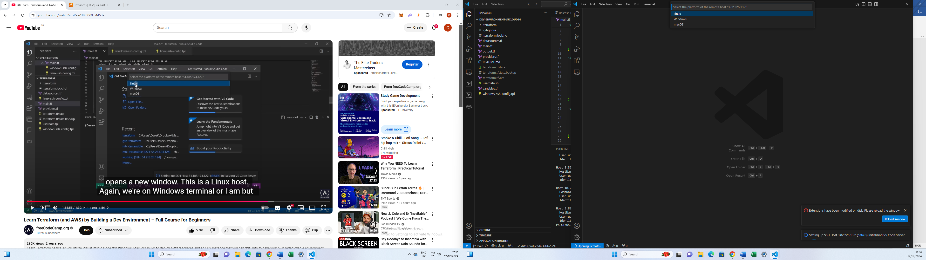

**Step 3:** you can check if docker is installed on your machine by writing “**docker --version**” in the terminal.

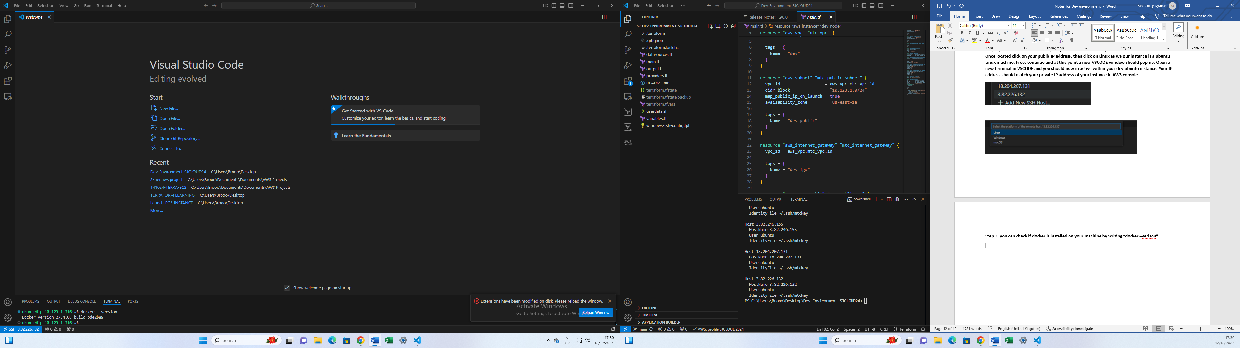

1. **Adding Outputs**

To avoid manually finding the public IP, add an output file (output.tf):

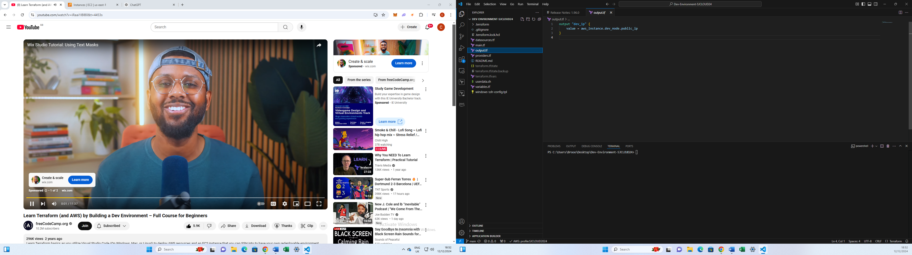

1. **Summary: Setting Up a Development Environment in AWS Using Terraform and VS Code**

Setting up a development environment in AWS using Terraform and VS Code offers a modern, efficient, and secure way to manage infrastructure and coding workflows. This approach combines Infrastructure as Code (IaC) practices with a flexible development environment, enabling automation, scalability, and consistency.

**Benefits**

1. **Infrastructure as Code (IaC) with Terraform:**
   * Automation: Terraform automates the provisioning and management of AWS resources, eliminating manual setup and reducing errors.
   * Consistency: The same Terraform scripts can be reused across environments (e.g., dev, test, production), ensuring predictable infrastructure.
   * Version Control: Terraform files can be stored in a Git repository, enabling version tracking and collaboration.
   * Scalability: Terraform allows for quick scaling of resources as your project grows.
   * Cost Efficiency: You can automate resource cleanup to avoid unnecessary expenses.
2. **Integrated Development Environment (IDE) with VS Code:**
   * Enhanced Productivity: VS Code extensions for Terraform and AWS simplify coding, linting, and debugging.
   * Seamless Integration: Extensions like Remote Development allow you to work directly in AWS-hosted instances.
   * Customizability: VS Code can be tailored to your specific needs with themes, extensions, and settings.
3. **Security Benefits:**
   * Centralized infrastructure management in AWS allows for better security monitoring.
   * Terraform ensures consistent security configurations across all deployed resources.
   * Role-based access control (RBAC) can be enforced using AWS Identity and Access Management (IAM).